Scenario | User Account | Screenshot
Landing page |  | 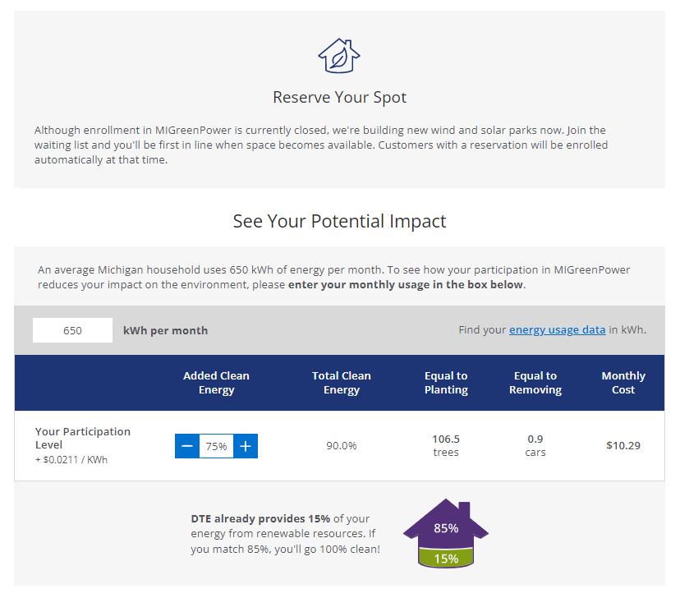  
Enrol | BP1100002376@DTEACCEPT.COM  CA: 920000471648  BP: 1100002376  GUID: 00505694630B1ED696ECDC4472729E60  POPUP: STEP 1  POPUP: STEP 2  ENROL: CONFIRMATION PAGE | 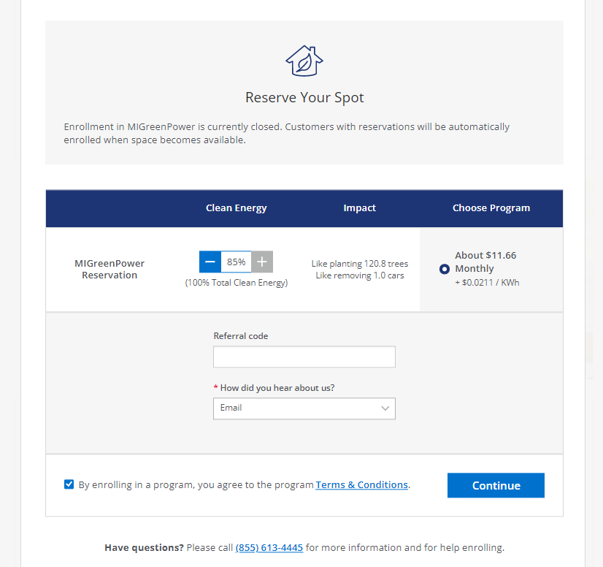  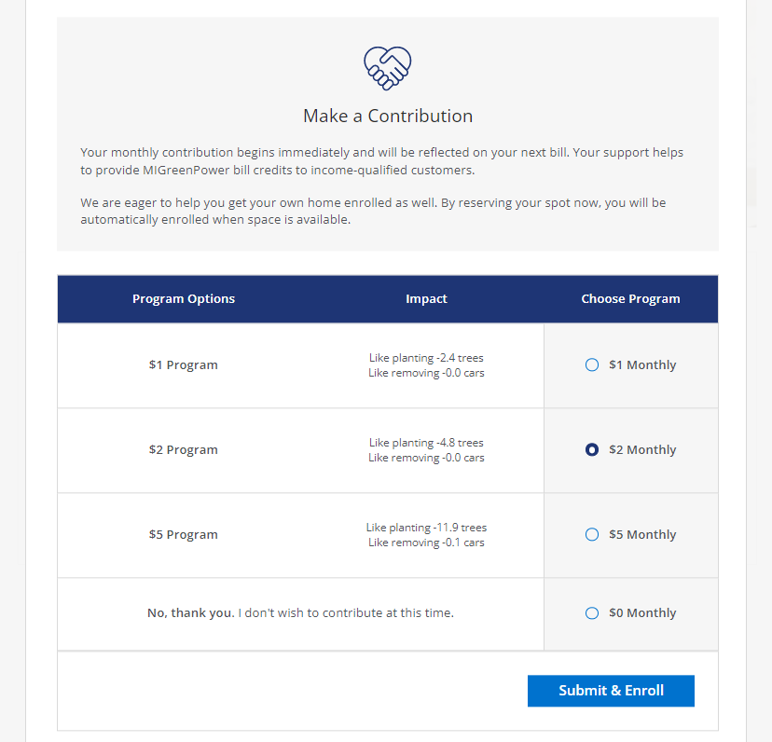  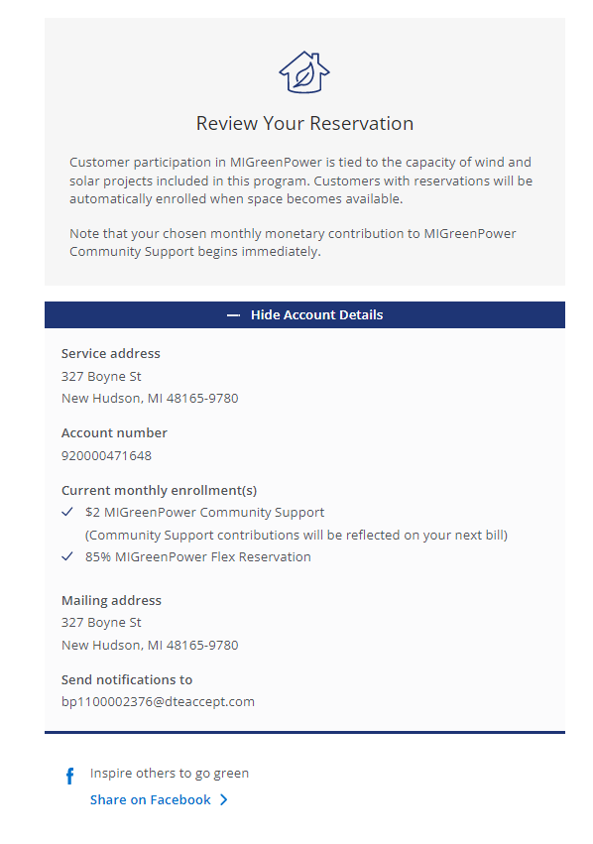  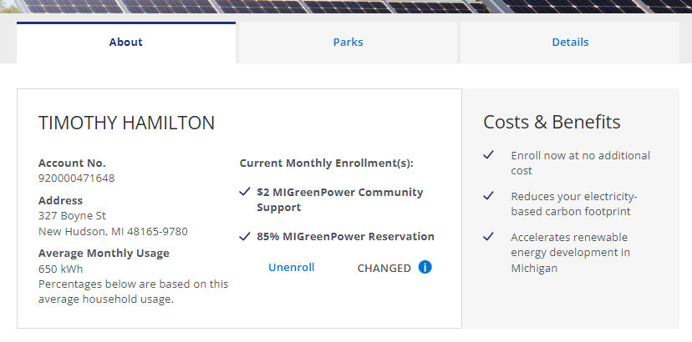
Unenroll | BP1100002376@DTEACCEPT.COM  CA: 920000471648  BP: 1100002376  GUID: 00505694630B1ED696ECDC4472729E60 | 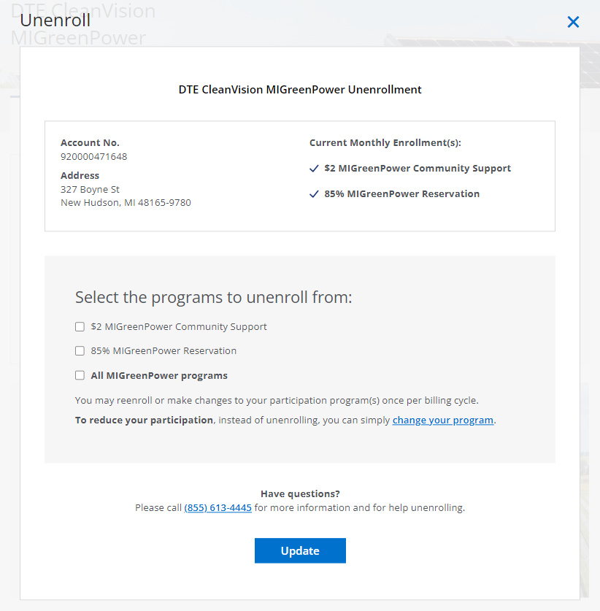  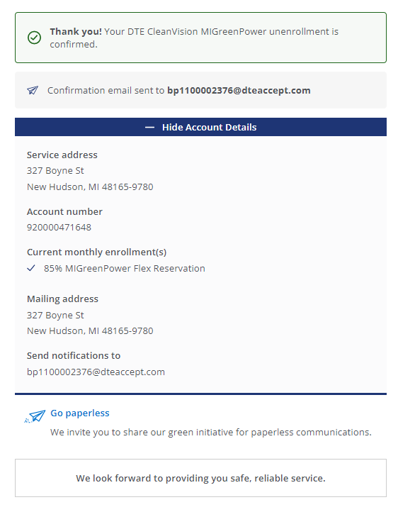
Change | BP1100002492@DTEACCEPT.COM  CA: 920000789445  920000789577  920000789858  920000790088  920000790377  BP: 1100002492  GUID: 0050569413831EE696ECDBA17F2208B9  0050569413831EE696ECDBA17F2188B9  0050569413831EE696ECDBA17F2108B9  0050569413831EE696ECDBA17F2088B9  0050569413831EE696ECDBA17F2008B9  0050569413831EE696ECDBA17F1F88B9  0050569413831EE696ECDBA17F1F08B9  0050569413831EE696ECDBA17F1E88B9 | 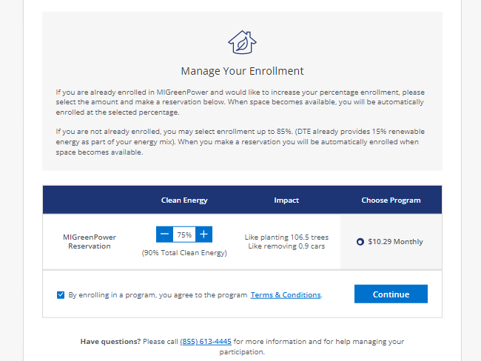  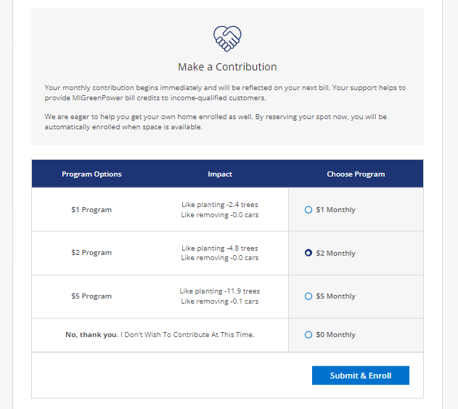  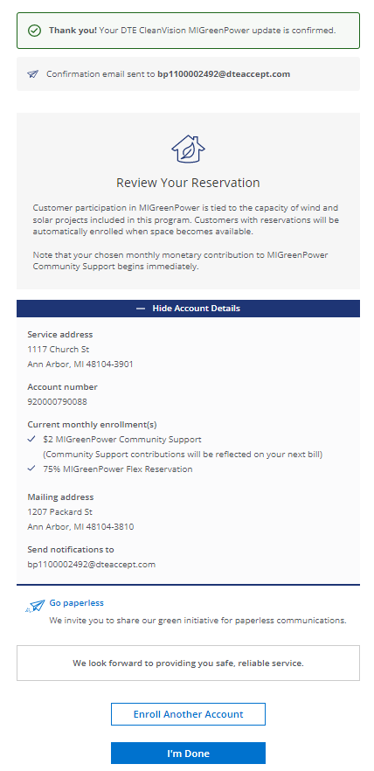
Single Account, No Enrolment | BP1100002376@DTEACCEPT.COM  CA: 920000471648  BP: 1100002376  GUID: 00505694630B1ED696ECDC4472729E60 | 
Single Account, Enrolled, Change Eligible | BP1100002489@DTEACCEPT.COM  CA: 920001229243  BP: 1100002489  GUID: 0050569413831EE696ECDB98D25EC8B9 | 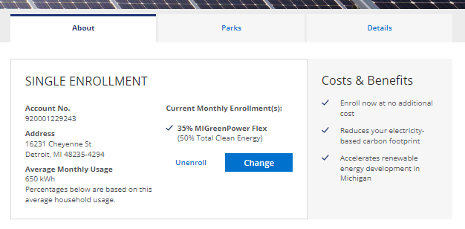  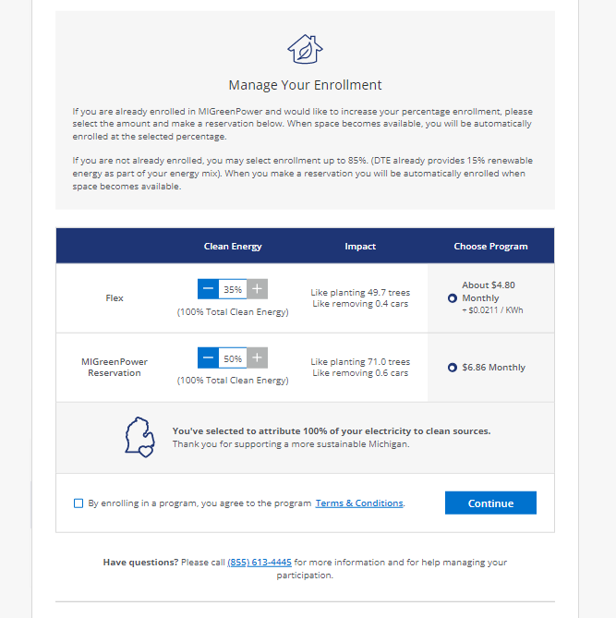
Single Account, Enrolled, Change Ineligible | BP1100225258@DTEACCEPT.COM  CA: 910000212571  BP: 1100225258  GUID: 00505694390B1EE696ED77FD70F5086A
Single Account, Enrolled, Unmetered | BP1100002759@DTEACCEPT.COM  CA: 920001202273  BP: 1100002759  GUID: 0050569413831EE696ECDC0FD58768B9 | 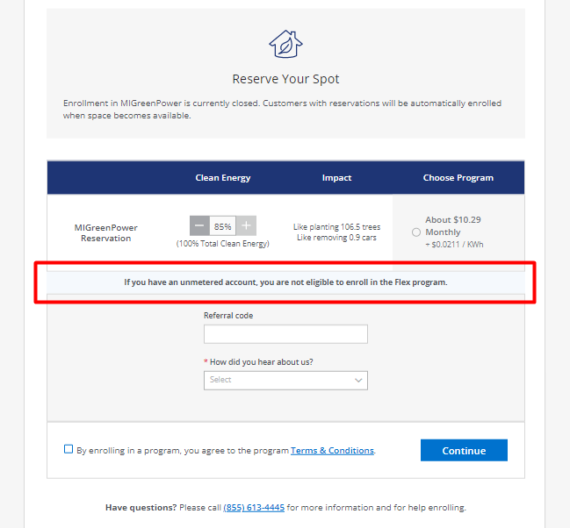
Multiple Accounts, Not Enrolled | BP1100002492@DTEACCEPT.COM  CA: 920000789445  920000789577  920000789858  920000790088  920000790377  BP: 1100002492  GUID: 0050569413831EE696ECDBA17F2208B9  0050569413831EE696ECDBA17F2188B9  0050569413831EE696ECDBA17F2108B9  0050569413831EE696ECDBA17F2088B9  0050569413831EE696ECDBA17F2008B9  0050569413831EE696ECDBA17F1F88B9  0050569413831EE696ECDBA17F1F08B9  0050569413831EE696ECDBA17F1E88B9 | 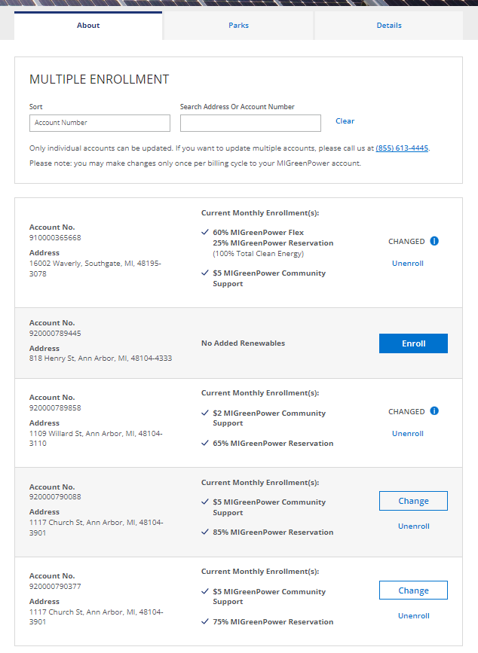
Multiple Accounts (>5 accounts), Mixed Enrolments | BP1100195719@DTEACCEPT.COM  CA: 910000212035  910000212142  910000212415  910000212431  910000212456  910000212480  BP: 1100195719  GUID:  005056941B4E1ED696ED6A92883F7ECD  005056941B4E1ED696ED6A92883FFECD  00505692762C1ED984D08DEF4A7C9E92  00505692762C1ED984D0E570EDC4DEDF  00505692762C1ED984D1784DDC083F5B  00505692762C1ED984D1B15B3FFB9F8D  00505692762C1EE984E1468A90498E88  00505692762C1EE9859E59790CCA4943  00505692762C1EE985AD91865D99B875  00505692762C1EE985B5A7E7A1E49FC5  00505692762C1ED985B5E05DD53B6003  00505692762C1ED985B5FD20FF0FE020  00505692762C1ED985B62D992BA4E044  00505692762C1ED985B6B939005CA0D4  00505692762C1EEA83F2702767A9A3EE | 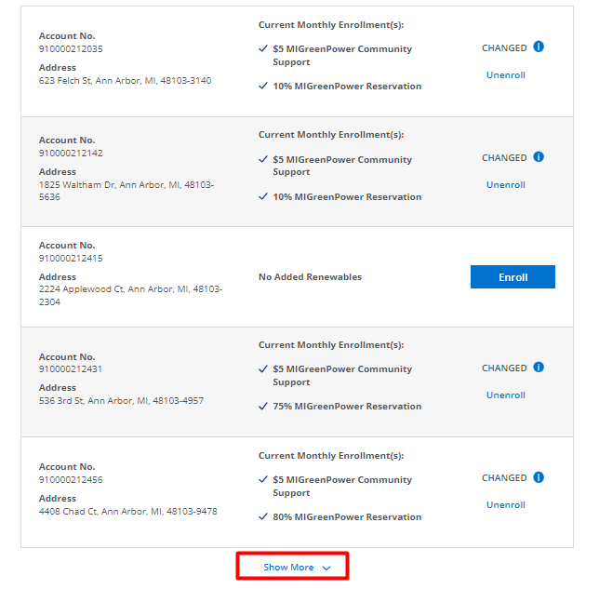
Guest Enrol | BP1100002685@DTEACCEPT.COM  BP: 1100002685  CA: 920001623791  GUID: 0050569413831EE696ECDBD91C2068B9  First name: PAULETTE  Last name: JACKSON  SSN: 111389406 | 